**Lab # 08**

**8-bit Ring Counter On Seven Segment Display**

CSE-308L [DIGITAL SYSTEM DESIGN LAB](https://classroom.google.com/c/NTk1NjYyOTEyNzU5)

**Name: Maaz Habib**

**Reg No: 20PWCSE1952**

**Section: C**

**Submitted to:**

**Engr. M. Usman Malik**

Department of Computer Systems Engineering

University of Engineering and Technology, Peshawar

**Objective**

To Implement an 8 Bit Ring Counter on Spartan 3 FPGA starter kit to show its output on the seven-segment display.

**Lab Task**

Implement an 8-bit ring counter on the seven-segment display.

**Code**

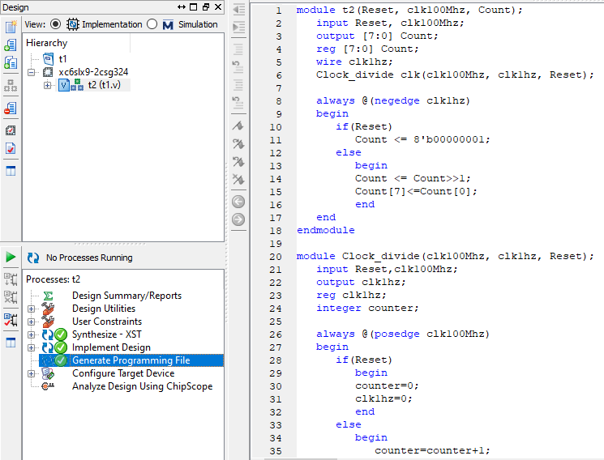 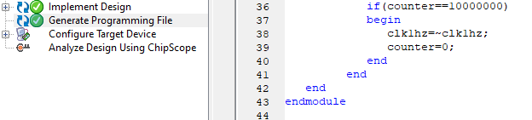

**User Constraint File(ucf)**

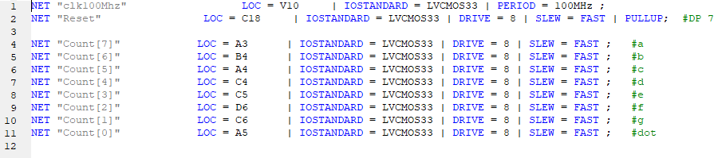

**Output**

